# **Guide for Lab 7 (Question 2)**

In the following question you have to read a txt file at command line or standard input and return the no of words in that file. I have attached a text file (novel.txt) in Lab 07 Submission on LMS. You have to go through the following commands for running question 2:

1. Install **MSYS2** on your system through the following link:

[**https://www.freecodecamp.org/news/how-to-install-c-and-cpp-compiler-on-windows/**](https://www.freecodecamp.org/news/how-to-install-c-and-cpp-compiler-on-windows/)

1. Through this installation, **g++ compiler and debuggers** will get installed on your Windows.
2. After this, open **CMD** (Command Prompt) and write the following command to check g++ version that you just installed on your system.

**g++ --version**

It will give you an output like this:

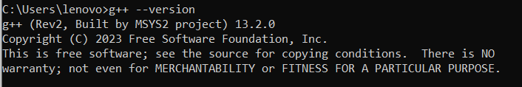

1. Now write the code for checking the no of words in a given string. Save the **cpp file and text file** in same location e.g **Desktop**
2. Now in CMD, first navigate to the Desktop or the folder where you have saved both the files through this command:

**cd Desktop**

1. After navigating to the desired location, write the following command and suppose you have saved your **cpp file** named as “**words.cpp**” and text file as “**novel.txt**”.

**g++ words.cpp -o words**

This will compile your program and an executable file will be made. After this, write this command:

**words.exe < novel.txt**

This will generate the following output:

